#7 Days of quaranteecode

# Stay Home

# FightNcov

# Day 1

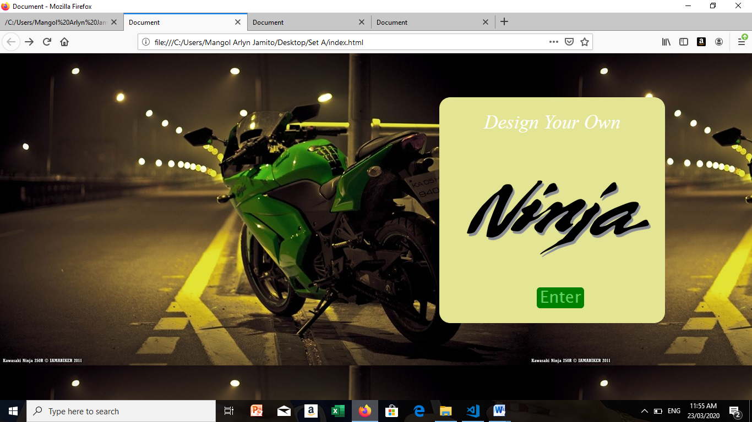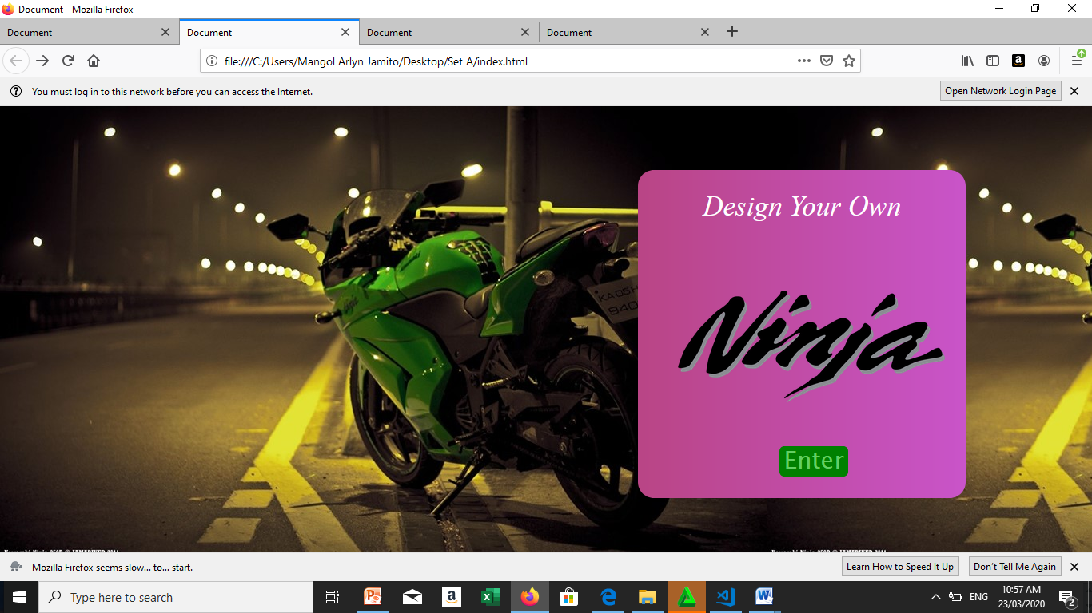

#7 Days of quaranteecode

# Stay Home

# FightNcov

# iKADos

#7 Days of quaranteecode

# Stay Home

# FightNcov

# Ikatres

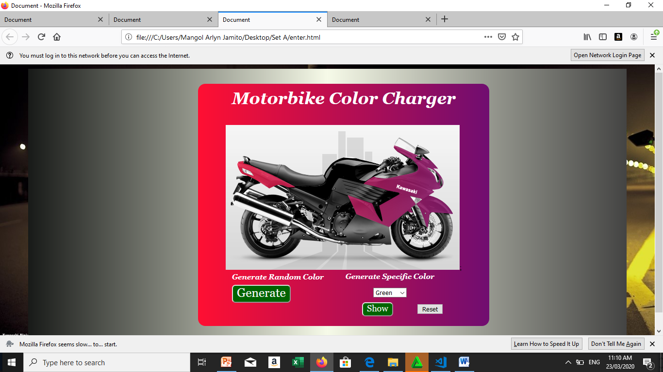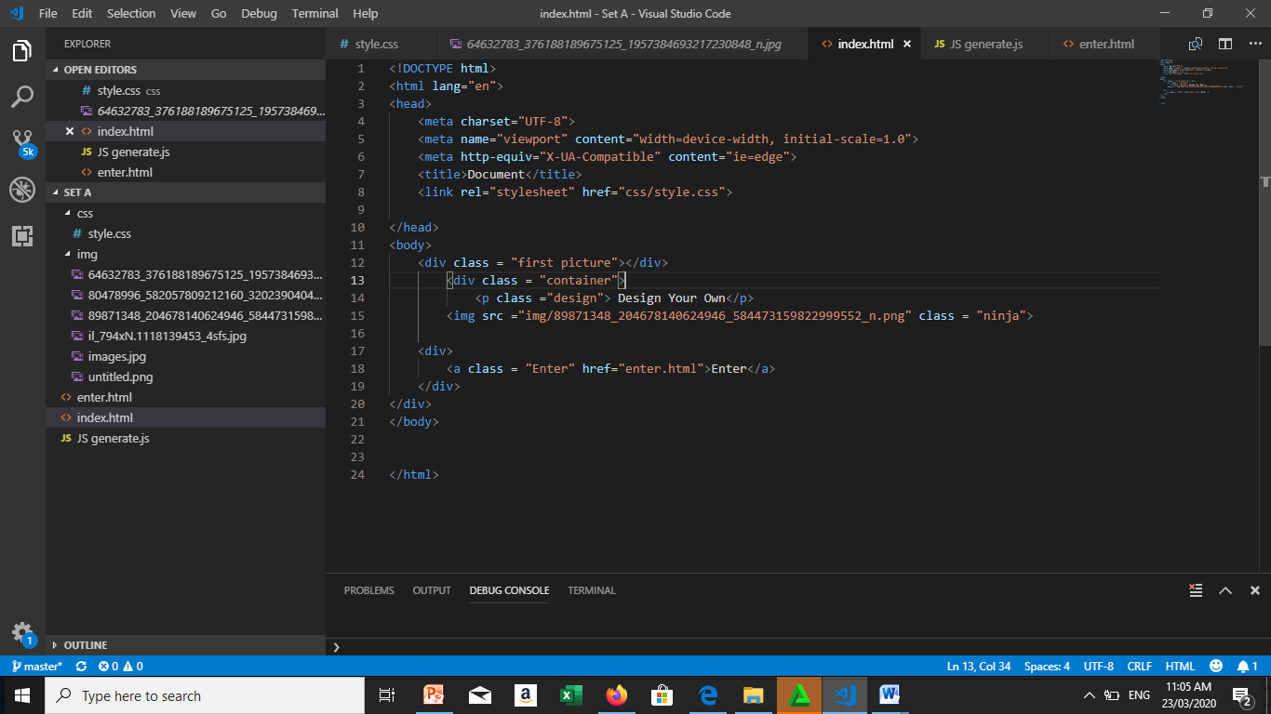

#7 Days of quaranteecode

# Stay Home

# FightNcov

# Ikafour

#7 Days of quaranteecode

# Stay Home

# FightNcov

# Ikanlima

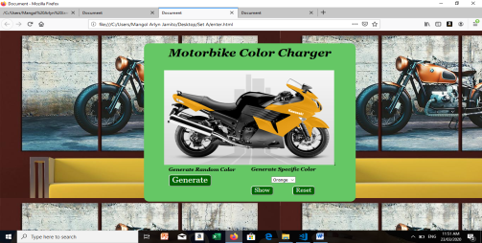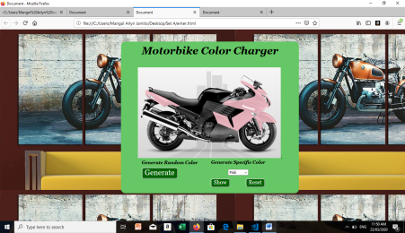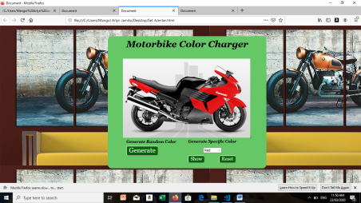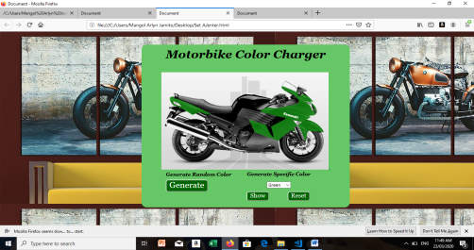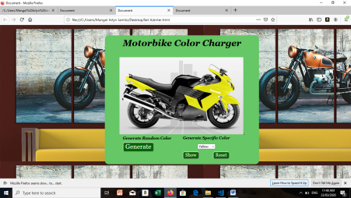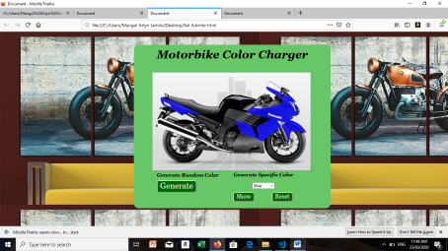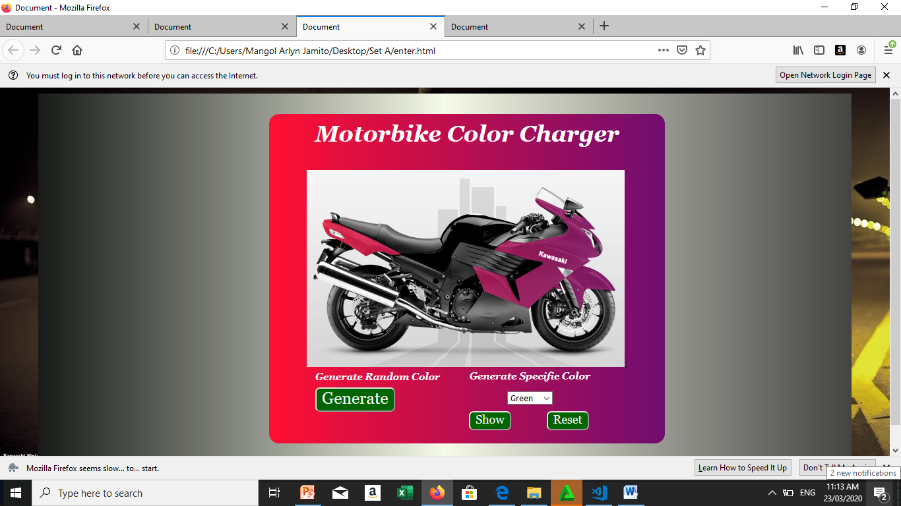

#7 Days of quaranteecode

# Stay Home

# FightNcov

# Ikanim/ikapito

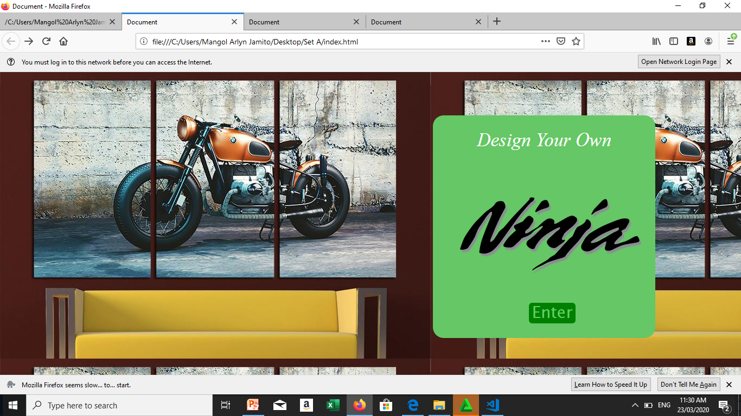s